Lab manual – Login to Windows EC2 instance

Open the Remote Desktop connection application

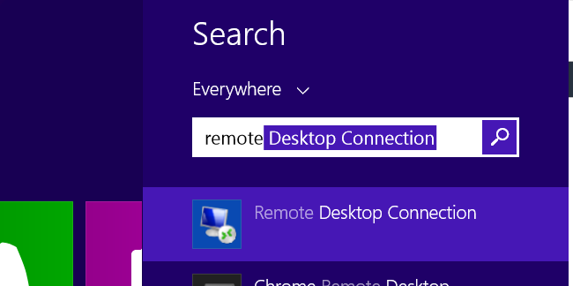

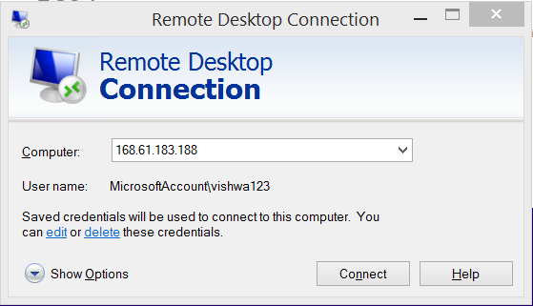

Enter the **“ipaddress”**

For windows machine, we cannot use the “private key” that was generated in the AWS for login to instance.

So , we hve to convert the private key to normal password.

Click on ‘**Connect’**

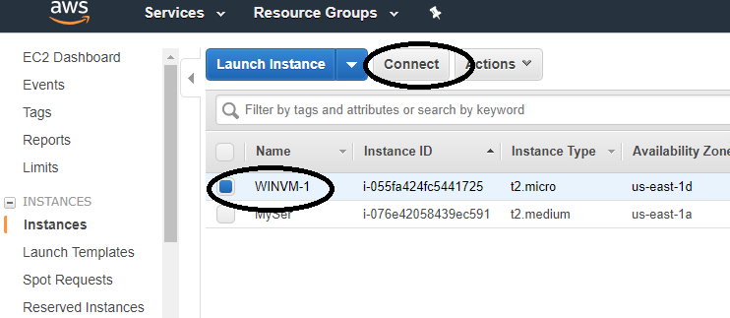

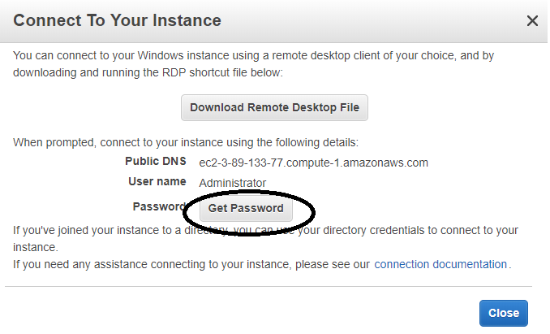

Click on **“Get password”**

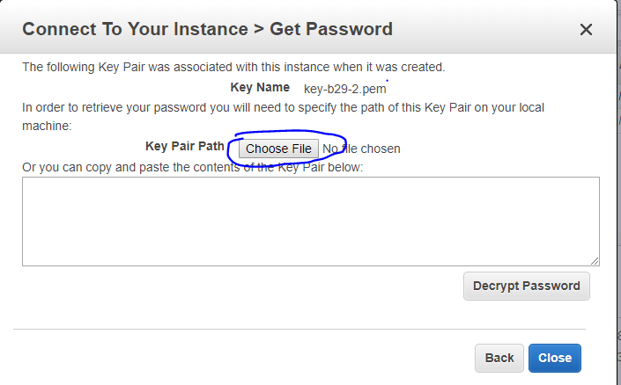

Click on **“Choose file” and select the “.pem” private key that is downloaded.**

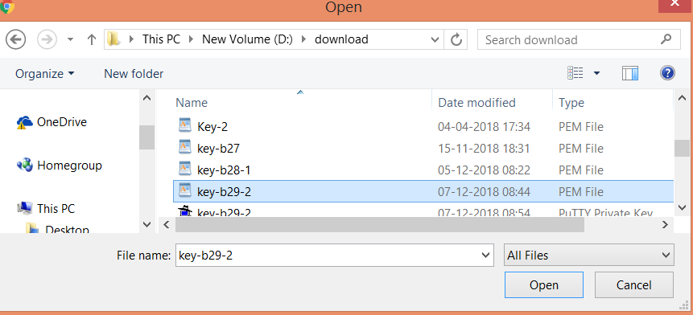

And Click on **“ok”**

Now click on **“Decrypt password”**

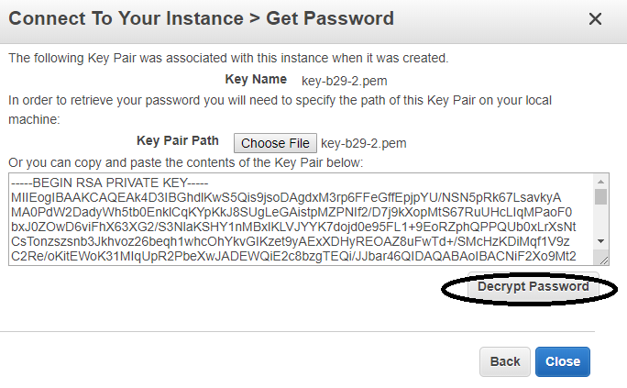

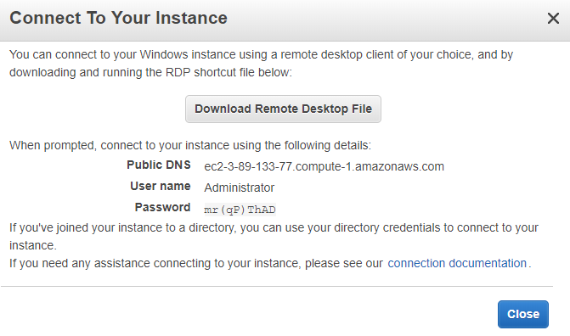

The username and password would be the details for your windows EC2 instance.

And you should be able to login via that for **future logins as well.**

Go back to your remote desktop connection application.

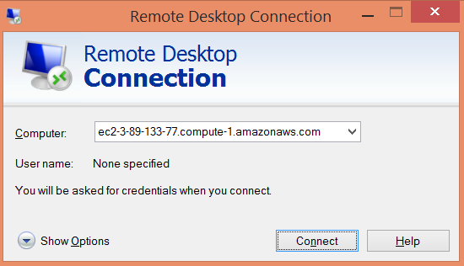

Click on **“Connect”**.

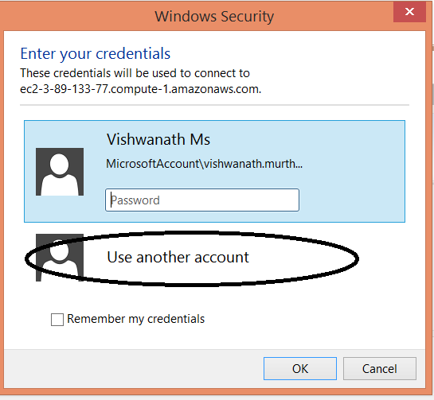

Click on **“use Another account”**.

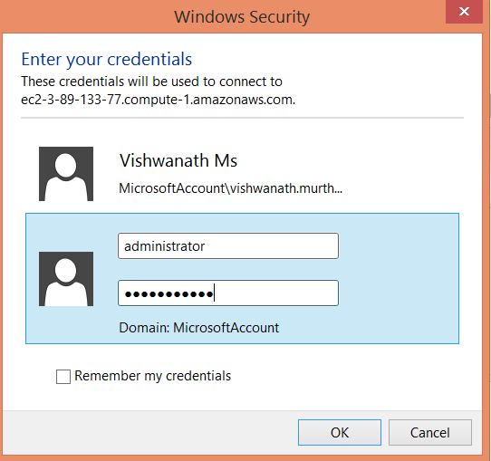

Click on **“OK”**.

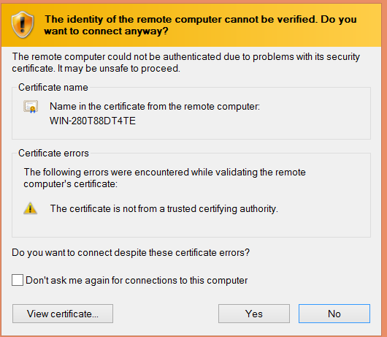

Click “Ok” on this screen to verify the connection.

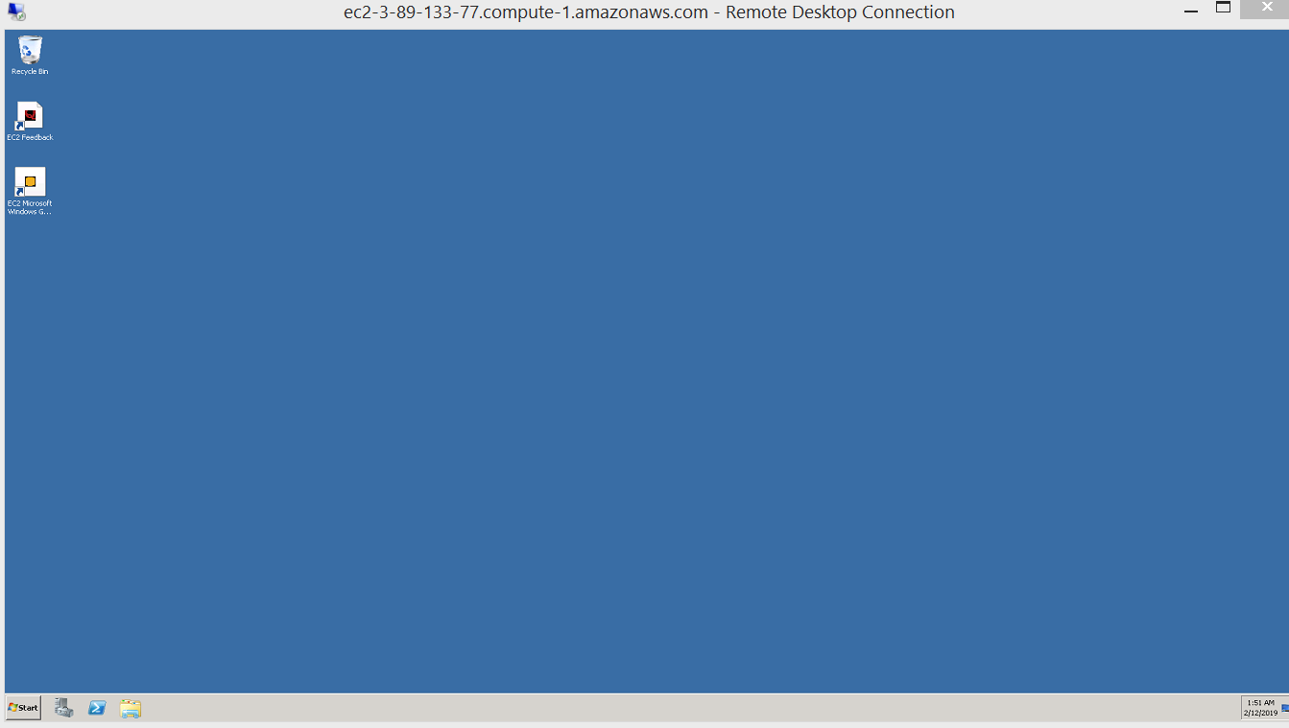

This should be the remote desktop connection of the Windows EC2 instance.